ARTIFICIAL INTELLIGENCE
Task 1: Language Translation Tool

A Technical Project Report

Student Name: | Tayyaba
Student ID: | CA/DF1/202587
Course : | Artificial Intelligence
Submitted To: | CodeAlpha
Tools: | Python, Google Colab
Date: | 30-07-2026

1. Objective
The objective of this task is to build a language translation application powered by an AI translation API. The tool allows a user to input text, select a source and target language, and view the translated output. As a bonus feature, the application also supports text-to-speech playback of the translated text.

2. Tools and Technologies Used
Component | Details
Language | Python (Google Colab)
Translation API | Google Translate, accessed via the deep-translator library
Bonus Feature | Text-to-Speech using gTTS (Google Text-to-Speech)
Audio Playback | IPython.display.Audio

3. Features Implemented
- Accepts free-form text input from the user.
- Allows the user to specify any source and target language code (not restricted to a fixed list).
- Translates text using the Google Translate engine via deep-translator.
- Displays the translated text to the user.
- Validates empty input and gracefully handles invalid language codes or API errors using try/except.
- Runs in a continuous loop so multiple translations can be performed until the user types 'exit'.
- Bonus: Converts the translated text to speech and plays it back directly in the notebook.

4. Methodology / How It Works
The application follows a simple, loop-based workflow:
- The user is prompted to enter the text they want translated.
- If the user types 'exit', the program terminates; empty input is rejected with a warning.
- The user provides a source language code and a target language code (e.g., en, ur, fr).
- The GoogleTranslator class from deep-translator sends the text to the Google Translate API and returns the translated result.
- The translated text is printed to the console.
- The user is asked whether they would like to hear the translation. If yes, gTTS converts the text to an MP3 file, which is played back using IPython's Audio widget.
- Any errors (invalid codes, network issues, unsupported audio language) are caught and reported without crashing the program.

5. Final Code
!pip install deep-translator gTTS

from deep_translator import GoogleTranslator
from gtts import gTTS
from IPython.display import Audio, display

while True:

text = input("Enter text (type exit to stop): ").strip()

if text.lower() == "exit":
print("Exiting Translator. Goodbye!")
break

if text == "":
print("⚠️ Please enter some text to translate.\n")
continue

source = input("Source language code (e.g. en, ur, fr, ar, es, de, hi, zh-CN): ").strip().lower()
target = input("Target language code (e.g. en, ur, fr, ar, es, de, hi, zh-CN): ").strip().lower()

try:
translated = GoogleTranslator(source=source, target=target).translate(text)

print("\nTranslated Text:")
print(translated)

# Bonus: Text-to-Speech output
speak = input("\nDo you want to hear the translation? (y/n): ").strip().lower()
if speak == "y":
try:
tts = gTTS(text=translated, lang=target)
tts.save("translated_audio.mp3")
display(Audio("translated_audio.mp3", autoplay=True))
except Exception as e:
print(f"⚠️ Could not generate audio for this language: {e}")

print("\n" + "-"*40 + "\n")

except Exception as e:
print(f"⚠️ Translation failed. Please check your language codes.\nError: {e}\n")

6. Sample Output

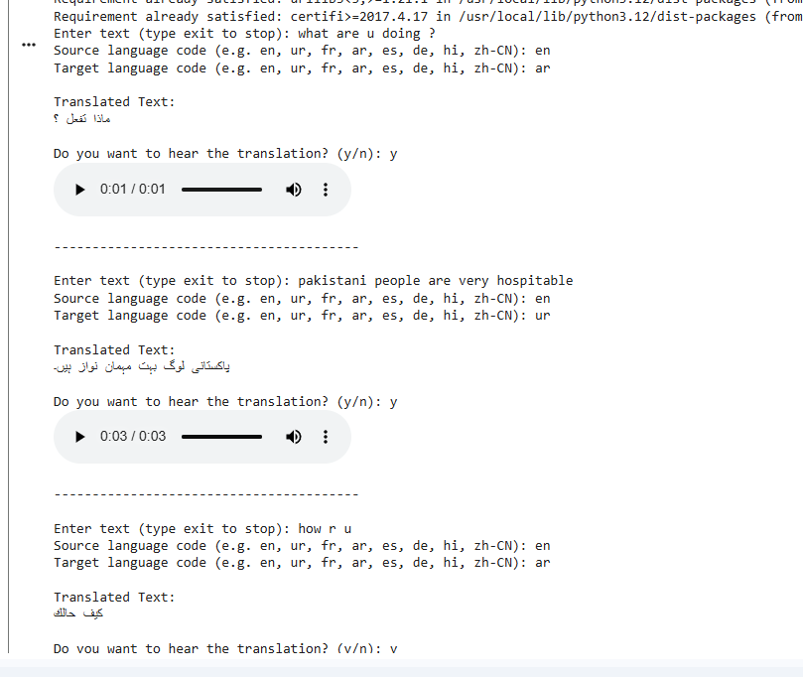

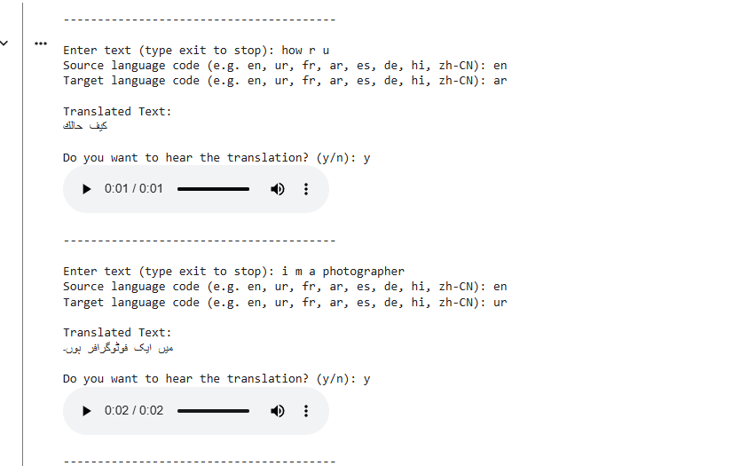

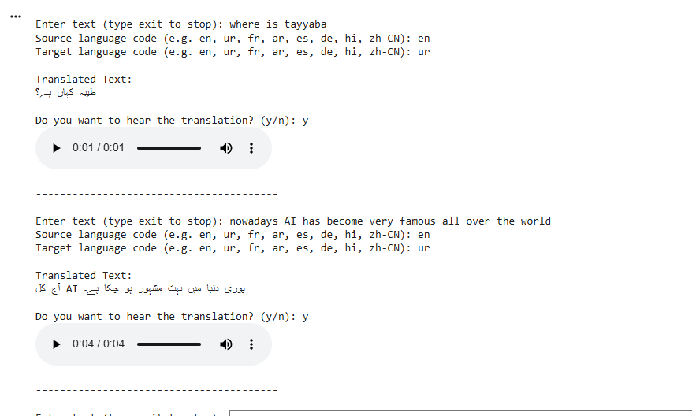

7. Conclusion
This task successfully demonstrates the use of an AI-powered translation API to build a functional, interactive language translation tool. The application meets all core requirements — text input, language selection, and translated output — and extends beyond them with a text-to-speech bonus feature, along with robust error handling for a smoother user experience.

